RESISTORS

**DEFINITION**

Resistors are those idealized elements which are the simplest passive element in a circuit. Resistors basically resist the flow of current through themselves.

**SYMBOL**

The symbol of a resistor in a circuit is:

**OHM”S LAW**

Georg Simon Ohm, a German scientist described the relationship between the potential difference across resistor and current through it.

According to Ohm’s law,

V(potential diff.)=i(current) * R(resistance)

The constant of proportionality R is called resistance, whose unit is ohm, which is 1 Volt/Ampere and abbreviated by capital omega, Ω.

When the Ohm’s law equation is plotted with current on y-axis and voltage on x-axis, a straight line is obtained, whose slope is 1/R.

**RESISTIVITY**

Resistance= P* L/A

Where p= resistivity of the material.

L= length of resistor.

A=cross sectional area of resistor.

**POWER**

Power absorbed by a resistor is given by Vi or i2R or V2/R. Energy is released by the resistor in form of heat.

**CONDUCTANCE**

Conductance of a resistor is defined as 1/R Siemens.

SOURCES

Sources we are going to discuss are:

1)voltage source

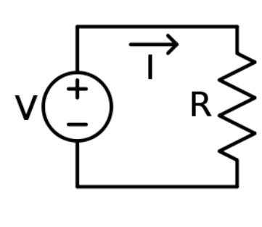DC voltage source

2)current source

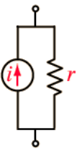DC source

each of them may be an independent source or dependent source

independent sources supply constant current/voltage irrespective of what is connected to it, unlike the dependent sources whose values will change according to the elements they are connected to again each of the dependent source can be of two types

1) current dependent

2) voltage dependent

a)current dependent voltage source:In this source the value of the voltage supplied by it depends on the current in a particular element

here the constant k which is multiplied to the currents has units “ V/A”

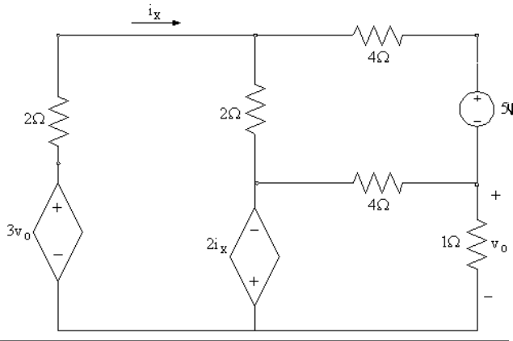

b)voltage dependent voltage source:In this source the value of the voltage supplied by it depends on the voltage in a particular element

here the constant k which is multiplied to the currents has no units

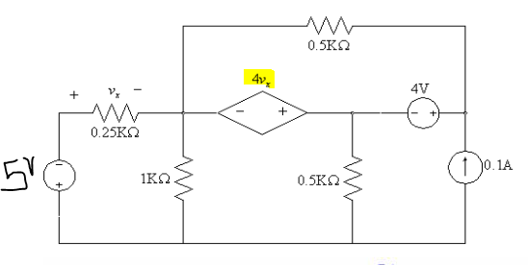

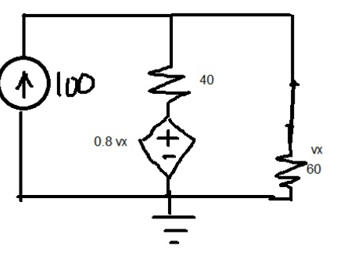

c) current dependent current sources: In this source the value of the current supplied by it depends on the current in a particular element

here the constant k which is multiplied to the currents has no units

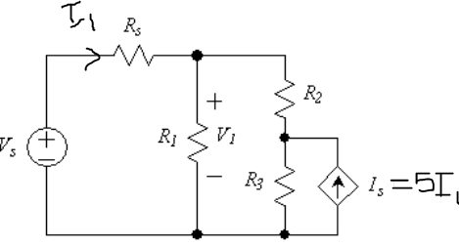

d)voltage dependent current sources: In this source the value of the current supplied by it depends on the voltage in a particular element

here the constant k which is multiplied to the currents has units “ A/V”

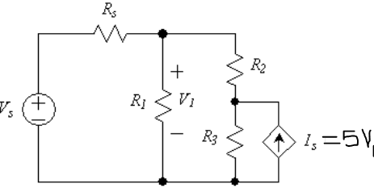

If current sources are in parallel we add them up

If voltage sources are in *series* we add them up.

CAPACITORS

Topics:-

-What is capacitor and capacitance?

-Current through capacitor

-Capacitance in series and in parallel

-Equations related to capacitance

-What is capacitor and capacitance?

Capacitance in least scientific terms, is something that can store energy. Its in the form of 2 parallel plates placed very close to each other with an insulation material filling the gap between them, normally of infinite resistance. Its termed as a passive element for its inability to supply some positive average power over an infinite period of time.

Capacitance which has a unit of Farad(F), is used symbolically in equations as C.

*For a capacitor with,*

*A=Area of parallel plates*

*d=Distance between the plates*

*є=constant(8.854pF/m)*

C=Capacitance of capacitor

**C=A є/d;**

For a capacitor circuit;

**i=C (dv/dt)**

*dv/dt=rate of change of voltage between capacitor plates*

*i=current through the capacitor(at any instant)*

*C=Capacitance of the capacitor*

-Current through capacitor:-

Having talked of there being infinite resistance between capacitor plates; general doubt that arises is that how can the current than flow through a capacitor. This is a result of the fact that the current flowing through the capacitor is not obtained due to flow of electrons as in normal case; instead here things are more complicated and that there is a displacement current in the capacitor plates, arising due to time varying electric field between the capacitor plates due to accumulation and depletion of a specific charge on the two plates. This was first discovered by James Maxwell.

-Capacitance in series and in parallel:-

Series:

If there are n capacitors with ith capacitor of capacitance Ci , each in series than their equivalent capacitance is given as;

**1/Ceq.=1/C1 + 1/C2 + ... +1/Cn**

Parallel:

If there are n capacitors with ith capacitor of capacitance Ci , each in parallel than their equivalent capacitance is given as;

**Ceq.=C1 + C2 + ... +Cn**

-Some equations related to capacitance:-

1.)Integral I-V relation

**v(t)=(1/C)(∫ {i(t) dt}) + v(t0)**

2.)Energy storage

a) **w(t)=1/2 (C ∆(v2))**

b)**P=v i=Cv dv/dt**

INDUCTORS AND INDUCATANCE

**What is an inductor?**

An inductor  is a [passive](http://en.wikipedia.org/wiki/Passivity_(engineering)) [two-terminal](http://en.wikipedia.org/wiki/Terminal_(electronics)) [electrical component](http://en.wikipedia.org/wiki/Electronic_component) that stores [energy](http://en.wikipedia.org/wiki/Energy) in its [magnetic field](http://en.wikipedia.org/wiki/Magnetic_field).

It is also called [choke](http://en.wikipedia.org/wiki/Choke_(electronics)), coil or reactor.

**History and defining inductance**

In the early 1800’s the Danish scientist Oerested showed that a current carrying conductor produced magnetic field. Then Ampere proved that this magnetic field was linearly related to the current which produced it.

Some 20 years later Faraday and Henry discovered that a changing magnetic field could induce a potential difference in a neighboring circuit which was proportional to the time rate of change of current producing the magnetic field. The constant of proportionality is called inductance, symbolized by L,

**ε=Ldi/dt**

**+ vl -** **→I** **L L**

**Symbol for an inductor**

**Unit For Inductance**

H or henry or volt-second/ampere

**Energy stored in an inductor is given by**

E=Li2/2

**Proof**

P=vxi

=Lidi/dt

=>dE/dt=Ldi/dt

=>dE=Lidi

=>E=Li2/2

**Combinations of inductors**

**Series**

🡪i ……… ……..

V1, L1 V2, L2 V3,L3 …….

V=v1+v2+v3+……

Leqdi/dt =L1di/dt+L2di/dt+L3di/dt+…….

**Leq=L1+L2+L3+L4+…….**

**Parallel**

L1 L2 L3 ………….

i = i1+i2+i3+……..

∫vdt/Leq=∫vdt/L1+∫vdt/L2+………

=>**1/Leq=1/L1+1/L2+1/L3+………**

Picture Source: GOOGLE IMAGES

-------:

Lalit Kundu 201201062

Vihar Patel 201201064

Vanshika Srivastava 201201065

Yimmidisetti Bhargav 201201066